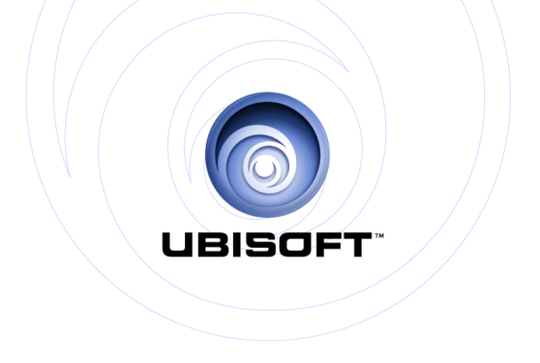

PRESENTS: **iOS**

**Android**

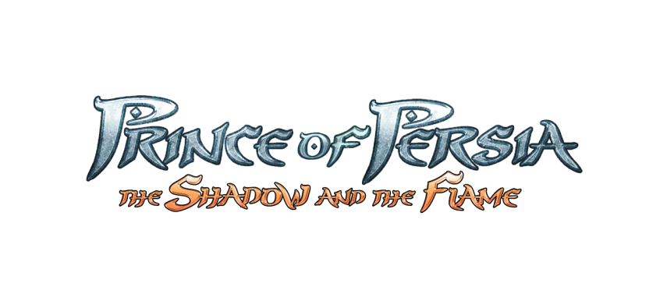

**PRODUCT DESCRIPTION**

Continue the age old saga of a wanderer who was born a Prince! The wanderer returns, in search of his unknown past on a journey to redefine his future.

Prince of Persia® The Shadow and The Flame is a pick up and play, smooth adaptation of an epic classic easy to handle but challenging to master. Play as the Prince who must battle the odds again to save his Princess and kingdom on a journey that will pave the path to his origins.

**KEY FEATURES**

* Rich and immersive atmospheres in various state-of-the-art enviroments
* Intuitive and dynamic gesture-based touch controls
* Smooth & acrobatic platforming
* Multiple enemy based combat with a slice of tactics
* New weapons & powers to acquire
* Explore 14 levels to unravel the story
* GameCenter Leaderboards (iOS)

|  |
| --- |
| **Product Specifications:**  Publisher: Ubisoft®  Developer: Ubisoft Pune  Release Date: July 25th  Languages : EFIGS + PORT (BR) + JP + KOR + RU + CN + AR + TK  Category: Action/Adventure Platformer  Platforms: iOS & Android  © 2013 Ubisoft Entertainment. All Rights Reserved. Based on Prince of Persia® created by Jordan Mechner. Ubisoft and the Ubisoft logo are trademarks of Ubisoft Entertainment in the U.S. and/or other countries. Prince of Persia is a trademark of Waterwheel Licensing LLC in the US and/or other countries used under license. |