***[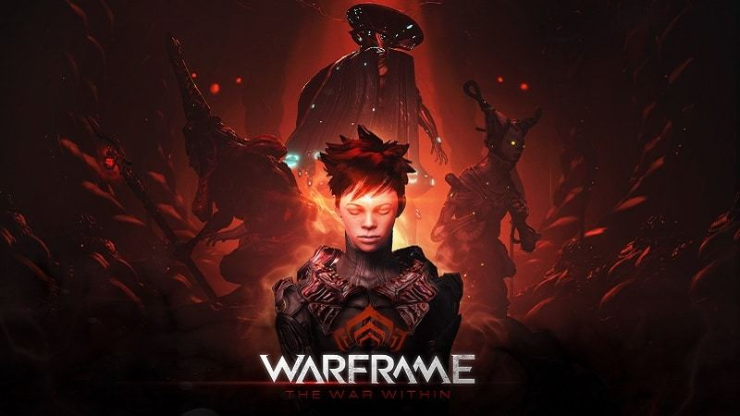](http://store.steampowered.com/agecheck/app/230410/)***

***WARFRAME: THE WAR WITHIN* LAUNCHES ON XBOX ONE AND PLAYSTATION 4 THIS DECEMBER**

*Millions of Players Prep for the Harrowing New Cinematic Quest and Can Enter to Win in Prime Gaming Giveaway Starting Today*

**LONDON, ON – December 1, 2016 –** Live from the Game Awards in Hollywood, California, independent developer and publisher Digital Extremes announced today the highly anticipated cinematic quest, [***The War Within***](http://store.steampowered.com/app/230410/), will hit ***Warframe*®** on Xbox One and PlayStation®4 this December for free. With its global community of more than 26 million registered players, the free-to-play action hit will take players on a chilling journey through a lore-filled cinematic quest including new missions, planets, enemies and more. To coincide with this announcement, Digital Extremes is launching a massive ***Warframe*** Prime Gaming Giveaway featuring complete, custom Prime Gaming Setups for PC, Xbox One and PS4™ as well as a chance to play the next Warframe Prime gear a week before its released to the public.



Digital Extremes released two new videos today for *The War Within* highlighting real player customizations and offering a glimpse of the new quest.

Download the new ***Warframe*** and *The War Within* for PS4™ and Xbox One trailers [**HERE**](https://digitalextremesltd.box.com/s/y8szfgkbgi6q63h7l6thltpkzmiricqy): [digitalextremesltd.box.com/s/y8szfgkbgi6q63h7l6thltpkzmiricqy](https://digitalextremesltd.box.com/s/y8szfgkbgi6q63h7l6thltpkzmiricqy)

Watch the videos on YouTube **HERE**: [www.youtube.com/watch?v=tuZpqdh-12I&feature=youtu.be](https://www.youtube.com/watch?v=tuZpqdh-12I&feature=youtu.be) and **HERE**: [www.youtube.com/watch?v=2odvaotDYGw&feature=youtu.be](https://www.youtube.com/watch?v=2odvaotDYGw&feature=youtu.be)

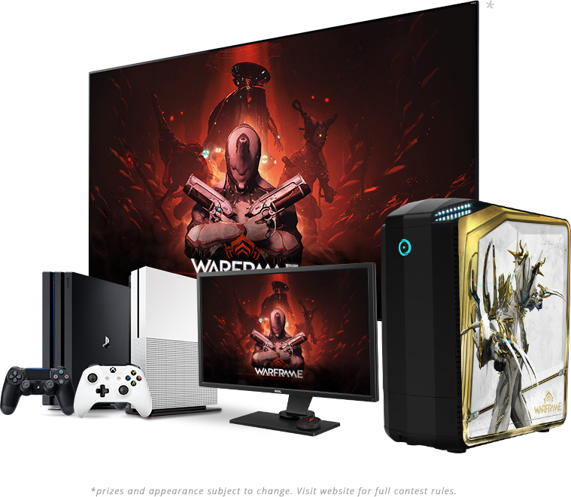

*The War Within* quest will push both Warframe and Operator past their limits as they venture into the Grineer Queen’s fortress to unravel mysteries about the Tenno’s past and hidden capabilities. These twisted Monarchs have lurked in the shadows, preferring to let their minions do their dirty work – but now it is time to uncover their true intentions face-to-face. In addition to the cinematic quest, *The War Within* update also includes new weapons, customizations, maps, and enemies, as well as a few secrets to be revealed closer to launch.

In order to play the quest upon its release, ***Warframe*** players must have completed *The Second Dream* quest and unlocked the Pluto-Sedna Junction. Digital Extremes also encourages players to ready their loadouts and don their best-dressed Warframe and Operator before playing their new cinematic journey. Players are encouraged to share their loadouts with the Dev team on *Warframe*'s official social media channels by tagging it with *#TheWarWithin*.

The free download of *The War Within* update will be available to PlayStation®4 and Xbox One players this December. An exact date will be revealed closer to launch.

PC players already have had a taste of the epic update, *The War Within*, released Friday, November 11, to record-breaking results. Hitting an all-time high of 68,530 concurrent players, ***Warframe*** rocketed into the top three games on Steam during release weekend.

As a thank you to the ***Warframe***community for their unending support, and in celebration of *The War Within*’s release on PlayStation®4 and Xbox One, Digital Extremes officially launched the ***Warframe*** Prime Gaming Giveaway during The Game Awards show. This spectacular giveaway will help ***Warframe*** players ramp up the quality of their game with an incredible array of custom Prime Gaming Setups*. Here is what our lucky Tenno could win:

* **Top-of-the-line Origin PC** with custom Prime-designed cases loaded with a GTX 1080 Founders Edition graphics card, Intel Core i7 6700k processor, 16GB of DDR4 RAM, and 24" monitor; plus Razer® peripherals and accessories
* **PS4™ Pro Gaming Setups** – Custom Prime-skinned PlayStation®4 Pro, Sony® 4K HDR 50" TV, Sony® Surround Sound system
* **Xbox One S Gaming Setups** – Custom Prime-skinned Xbox One S, 4K HDR 50" TV, Surround Sound system
* **Top Tier Prime Access Packs** (first release of 2017) to be delivered to your game account one week before its released to the public – Prime Access is a premium program offering instant access to the most coveted variants of Warframes and gear

To be eligible for a chance to win, players must log in to play ***Warframe*** between Thursday, December 1, 2016, and Wednesday, February 1, 2017, and fill out an official entry form on the official website at [www.warframe.com/en/giveaway](http://www.warframe.com/en/giveaway). ***Warframe*** Prime Gaming Sweepstakes is limited to residents of North America, Finland, France, Germany, Mexico, Norway, Russia, Switzerland and the United Kingdom. Some exceptions apply. Full details and rules are available here: [www.warframe.com/giveaway](http://www.warframe.com/en/giveaway).

Please visit the official ***Warframe*** website at [www.warframe.com](http://www.warframe.com) to join the Community and download the game. To keep up with the latest updates from the development team, be sure to follow ***Warframe*** on [Facebook](https://www.facebook.com/PlayWarframe), [Twitter](https://twitter.com/playwarframe) and [Instagram](https://www.instagram.com/playwarframe/).  
 **ABOUT DIGITAL EXTREMES**  
Founded in 1993 by James Schmalz, Digital Extremes ranks as one of the world's top independent development studios in the interactive entertainment industry. The Canadian-based developer has a rich history in developing some of the industry's top first-person shooter and action games. Originating with the co-creation of Epic Games' multi-million unit selling Unreal® franchise including Unreal, Unreal Tournament – and all its iterations – and continuing with such hits as Dark Sector®, BioShock® for the PlayStation®3 and the multi-player campaign of BioShock 2. More recently, Digital Extremes earned critical acclaim for the development of first-person shooter, The Darkness® II, based on the comic book series of the same name and the use of its proprietary technology, the Evolution Engine™.  The studio is currently developing and publishing the Free-To-Play action game, Warframe® available now on PC, PS4™ and Xbox One.  For more information about Digital Extremes, visit the company website at [www.digitalextremes.com](http://www.digitalextremes.com/). To sign up for Warframe, visit [www.warframe.com](http://www.warframe.com).

*\*Prizes and appearance subject to change. Visit* [*website*](http://www.warframe.com/giveaway) *for full contest rules.*

*# # #*

Add Media Contacts HERE